ANSWERS(ASSIGNMENT 5)

- A shell in the Linux operating system is a command-line interface that acts as an interpreter between the user and the Linux kernel, translating human-readable commands into instructions the kernel can execute. It processes user inputs, executes programs, and displays outputs.

CATEGORIES:

1.Bourne shell
2.C Shell
3.Korn shell
4.Bourne again shell(bash)
5.Z Shell

It is popular because:

1.Default shell in most Linux distributions
2.backward compatible with bourne shell.
3.supports command history, tab completion, scripting, aliases
4.highly portable and customizable

- The ls -Z command shows us the security context of each file in the directory.

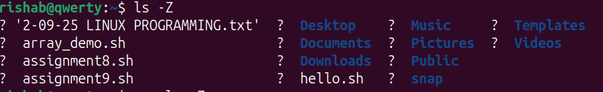

3)Command to list all the files in the directory : ls -a
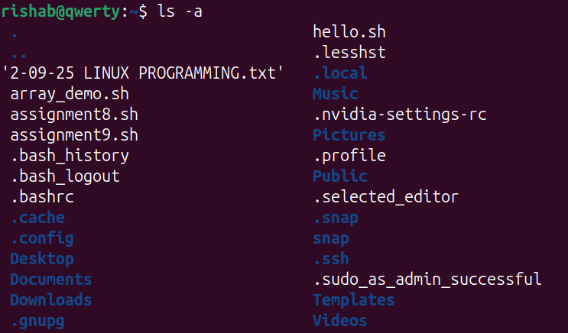

Hidden files in the directory start with ‘.’
The command to list only the hidden files in the directory is “ ls -d .* “

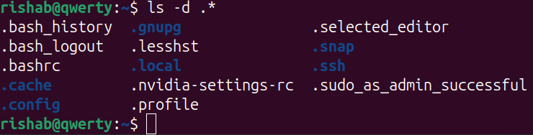

4) A hard link acts as a copy of the selected file. It accesses the data available in the original file. If the earlier selected file is deleted, the hard link to the file will still contain the data of that file. A soft link acts as a pointer or a reference to the file name. It does not access the data available in the original file. If the earlier file is deleted, the soft link will be pointing to a file that does not exist anymore.

HARD LINK

1.Data presented in the original file will still be available in the hard links.
2.If the original file is removed, the link will still work as it accesses the data the original was having access to.
3.Hard links are comparatively faster.

SOFT LINK

1.Soft links only point to the file name, it does not retain data of the file.
2.If the original file is removed, the link will not work as it doesn't access the original file's data.
3.Soft links are comparatively slower.

5) -rwxr-x–x
The 1st ‘-’ states that it is a file
‘rwx’ states that the owner can read, write and execute.
‘r-x’ states that the group can read and execute.
‘--x’ states that the others or user can execute only.

6)chgrp staff data.txt

7) 777 means the owner, group and others can read, write and execute any file on the system. Anyone using the system can do anything with any file on the system which is a security risk. They can delete the file or edit the file or even inject the file. Example:

chmod 777 data.txt Anyone on the system can read, edit or delete ‘data.txt’.

8)The ‘whatis’ command shows a short description of a specific command. Meanwhile the ‘apropos’ command searches manual pages for any keyword related to a topic.

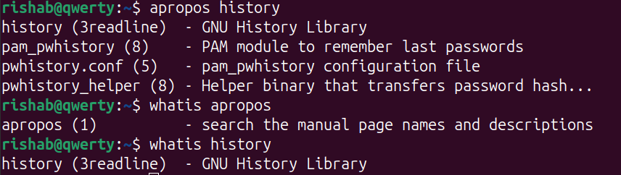

9)Lets take the wrong command as ‘histryy’

“ histryy 2> error.log ”
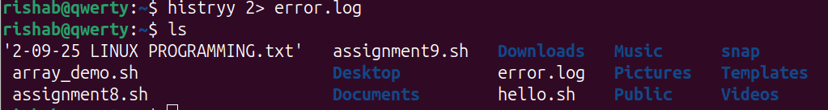

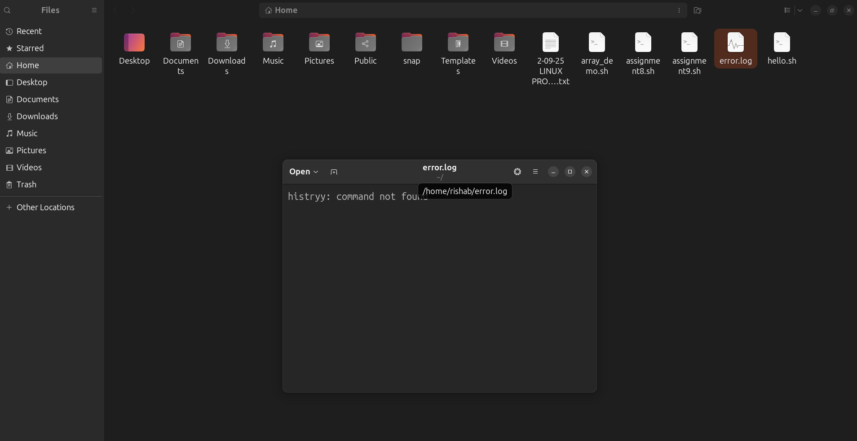

10)

